5-2 Coding Assignment: Certificate Generation

Romi’on Price
Southern New Hampshire University
CS-305: Software Security
Professor Thoma
June 7, 2026

- Why would you want to use a CA for security
- A CA or certificate authority ensures the website or server is authentic. The CA signs the certificate the server sends to the client and allows the client to trust the server after verifying that the CA signed the certificate. It is verified by the public key cryptography on which TLS is based. When the trust is established, a secure communication channel is created. Without a TLS or SSL certificate when sending personal information, your information could be accessed by unauthorized parties.
- What are the advantages of using a CA
- A CA provides trusted verification when communicating with new or authentic sources. It provides enhanced security with digital certificates issued by the CA to enable strong encryption to protect personal data. Ensures data integrity when data is in transmission. Also, many industries and regulations require digital certificates for security or compliance purposes.
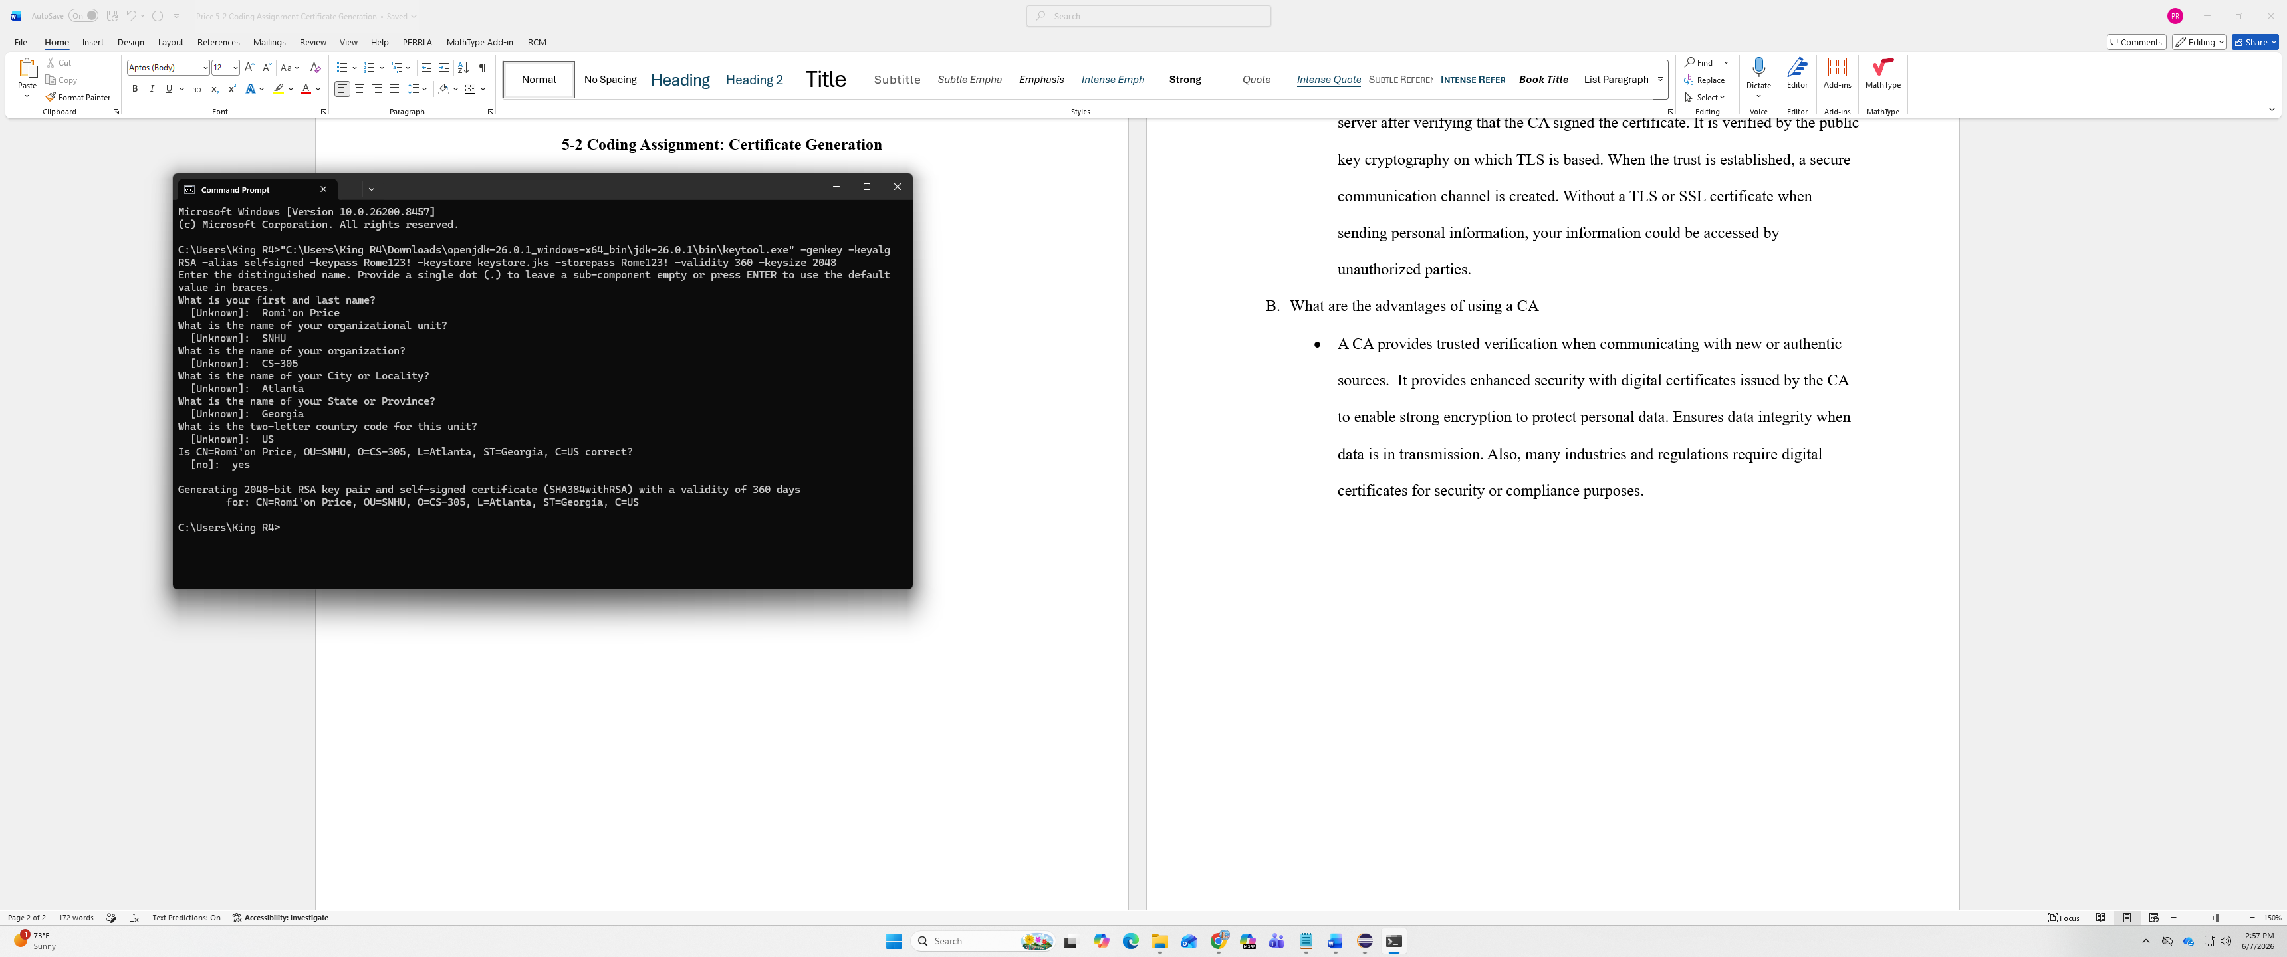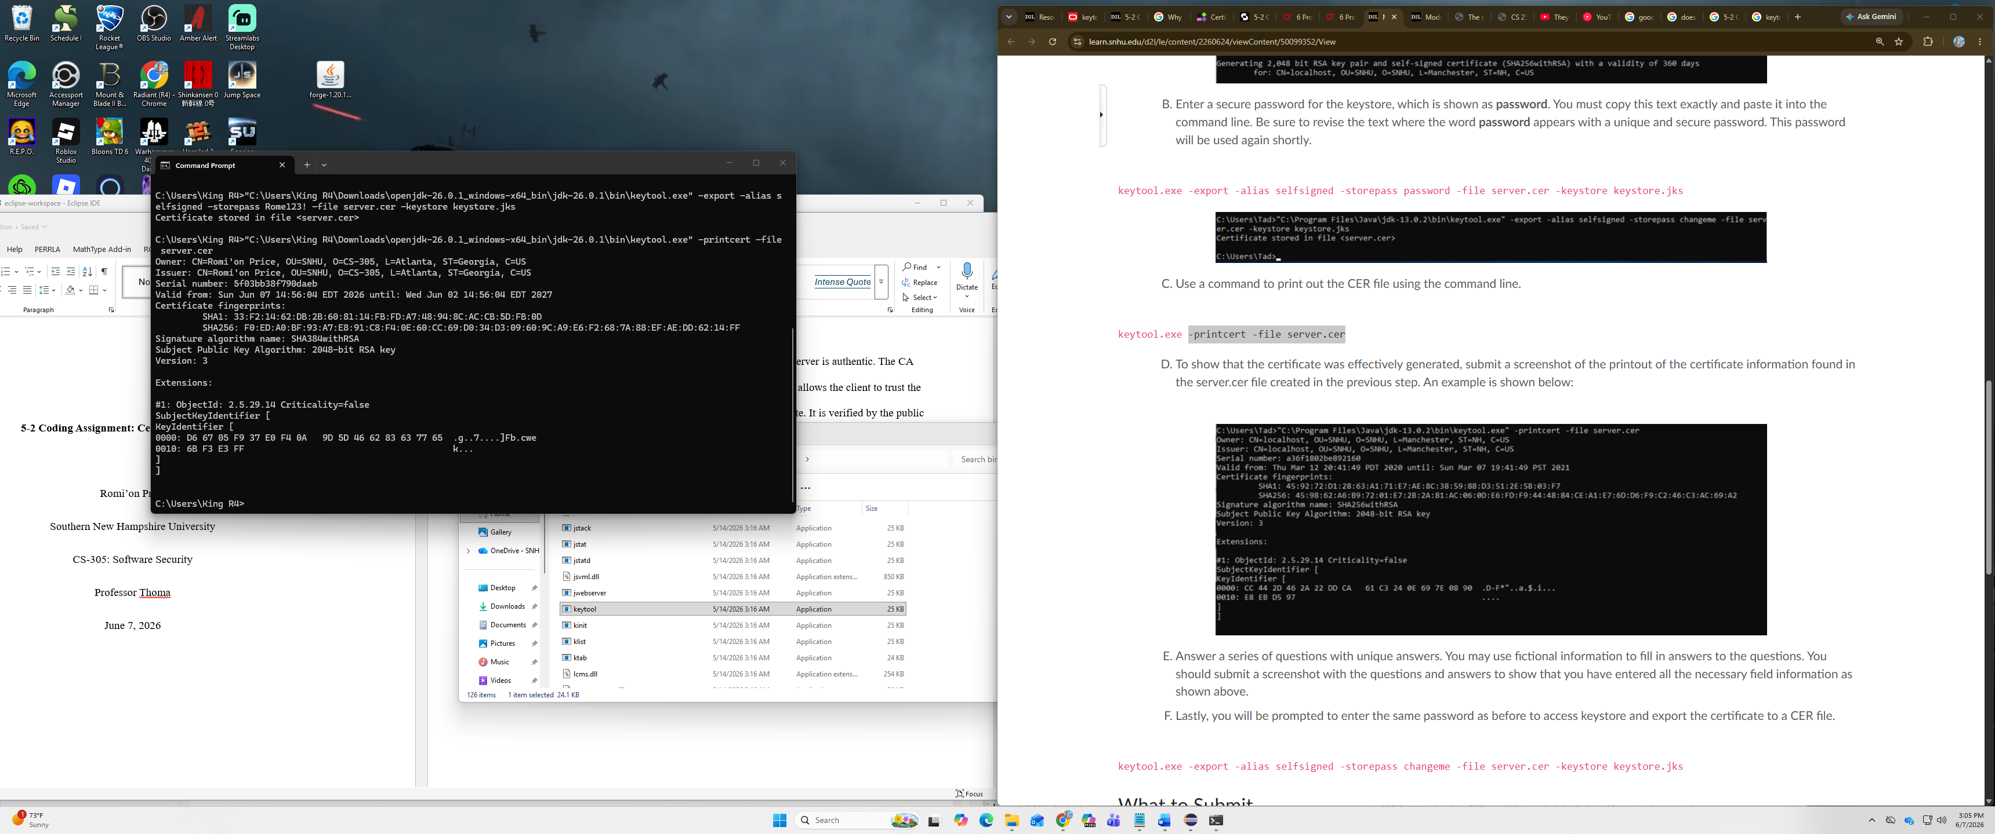

References
6 Protecting Sensitive Data - Iron-Clad Java [Book]. (n.d.). Www.oreilly.com. https://learning.oreilly.com/library/view/iron-clad-java/9780071835886/ch06.html#ch06lev1sec1
Certificate Authority - Entro. (2025, July 2). Entro. https://entro.security/glossary/certificate-authority/
‌

